|  |
| --- |
| **Current Year Approval Letter, Current Budget, and Renewal Application**  Tab 2 |
| **Form A-2- Management Plan**  Tab 3  **Renewal applications for the last 3 years** |
| **Form A-3 - Site Information Form(s)**  Tab 4 |
| **Form 003 - Permanent Agreement** |
| **Form 010 - Non-Pricing Meal Policy Statement**  Tab 5  **OR Form 011 – Pricing Meal Policy Statement** |
| **Form 015 - Certificate of Authority**  Tab 6 |
| **Form 035 - Civil Rights Questionnaire (2 page)**  Tab 7  **Form 036 – Civil Rights Questionnaires from subsequent years (short form)** |
| **Form 050- Food Service Vending Contract(s)**  Tab 8  **Form 040 - Disclosure & Certification Regarding Lobbying (if receiving $100,000+ in Federal $$)** |
| **IRS Tax Exempt letter (501 (c) 3 Notification)**  Tab 9  **OR Form 055- Title XX Certification; for Proprietary ''For Profit'' Centers** |
| 1. **State of NM Tax and Rev CRS Registration Certificate**   Tab 10   1. **Form 045 NM W-9 Form** |

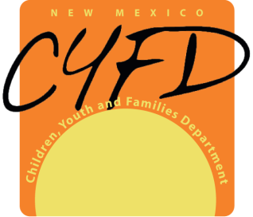 **Permanent Documents Binder Index**

Tab 1

Revised April ‘18

Permanent Documents for CACFP