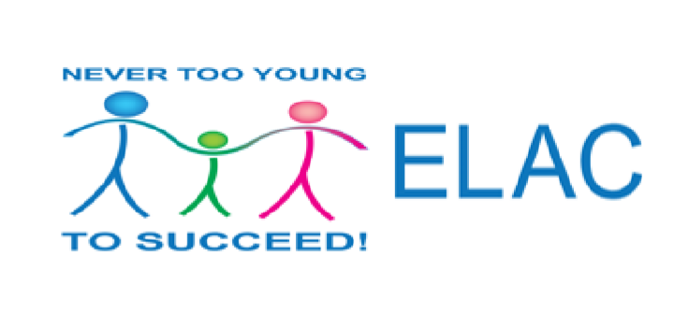

**NEW MEXICO EARLY LEARNING ADVISORY COUNCIL**

**(ELAC)**

**Meeting Minutes**

**April 10, 2017**

**Farm & Ranch Museum – Las Cruces NM**

Meeting was Call Order by Erica Stubbs, ELAC Chair, at 12:10 pm. She welcomed the participants and thanked Ray Jaramillo for the coordinating meeting logistics and Town Hall to follow.

Roll was called for the meeting. Present: Shannon Rivera, Andy Gomm, Erica Stubbs, Janis Gonzales, Michael Weinberg, Franz Joachim, Larry Langley and Alejandra Rebolledo Rea.

Zoom: Barbara Tedrow

Excused: Heather

Quorum established at 12:15 pm by Erica Stubbs.

Community introductions.

Motion to approve January 3, 2017 Minutes

Barbara Tedrow; Ray Second. No discussion. All in favor. Motion carried.

**Legislation Updates**

**Erica and Alejandra**

* Reauthorization of ELAC was vetoed – June 30, 2018 sunsets.
* Concern about training on open meetings act and reporting.
* HB2 authorizes the human services to collaborate with DOH and CYFD to streamline home visiting services and leverage funding.
* Medical assistance program in the Human Services Department shall pursue the necessary Federal authorities to establish any funded Home Visiting Program. The department should work in cooperation with the Early Childhood Services program.
* There are three proposed scenarios currently in play for Higher Ed
* Ready to Learn Initiative grant by the Department of Education through the Corporation of Public Broadcasting.
  + The proposal is a fully funded grant, however, public health and stations around the country are doing their own sessions with that. Accumulate funding from the station itself.
* Under the proposed scenario procure a 1% cut and under SB 182 5% budget proposed from the executive branch and incurably 0% from the Higher Ed because it’s not being funded at all.
  + Every one of those scenarios does impact our ability to continue to provide Early Learning Services through the regular programming.

**Memorial 23 Discussion**

* Second year of the memorial, it was introduced last year by Senator Campos.
* This year it was submitted with a few changes; it says it would like to take a look at the system of child care and that involves the PreK, Child Care, and Head Start.
* To better align services for 3 & 4 year olds. To use those services to the best of their advantage. The disproportionate funding is lead to financial stress.
* Originally tasked to be collaborated or brought together under one of the state agencies. Decided to be brought under the Early Learning Advisory Council because we were already starting this work with the subcommittee.
* Report due to the LESC and LFC by October 1, 2017.
* Subcommittee has begun working on this issue. Developed a work plan which includes:
  + Needs assessment
  + Work with CYFD and PED to learn how RFP process works
* Community Assessment, Professional Development, Mixed aged PreK, and Inclusion Practices are the four groups of the subcommittee.
* We want to find out what already happened in NM, work with the two departments CYFD and PED
  + Second research piece is from the providers to see how this works.
  + Also, look at other states; then ask ourselves-what do we know about the best practices? Is there something we can learn from other places that seem to be doing this well?
* It was suggested that ELAC and the subcommittees sit down with the State and look over the work that they have created, or the people that are running the groups and talk about how those two things will connect.
* There is an idea that there is a certain amount of competition from Head Start and PreK. Perception of difference in quality between these two.
* Head Start is now being able to offer a full day program opposed to half a day. Integrating Head Start data into the system will answer a lot of questions.
* The combined work with CYFD has already brought some positives, there are still some other conversations that need to be had.

**Early Learning Race to the Top PED Update**

**Brenda Kofahl and Terry Tapia**

* Focus Criteria Finalized in February.
* Data from the new Pre K database and HS data will be available 2018
* Web based training, ECERS, LETRS and ECOT
* Effective Early Literacy Instruction added
* Early Learning Guide aligned with Early Childhood Outcomes
* How are CYFD and PED aligning? Alejandra states CYFD has a sustainability plan and meets with staff and state consultation staff to align trainings. Where can they streamline? By offering more online training.
* Andy Question: How many schools are practicing the FOCUS guidelines? Four districts are fully embracing the inclusive model.
* Question: Will the work continue once RTTP ends? NM PreK will continue and Title I and Special Ed will continue with the remainder of the RTTP funds.
* Challenges: the size of the state with the amount of consultants – travel long distances.
* Successes: School districts in Jal, Farmington, Gallup and Clovis with no monetary incentive but recognition has gone a long way.

**Home Visiting Update**

**Selestte Sanchez**

* Level 1 RFP is out and due April 25th
* Level 2 Pilot underway – intervention focused to connect families to resources goal is to reduce the numbers of child abuse and neglect.
* Level 2 plus focusing on families in the NICU.
* McFee will either be fully federally funded or a combination of state and federal funding.

**Public Comment**

Claire Dudley – praised ELAC for taking on the task and requests to participate on the work groups.

Michael Weinberg – Soda Tax for Pre K in Santa Fe.

Shannon Rivera – asked Alejandra for an update on the Consultation Model RFP. Alejandra reported it is still in legal processing.

**Town Hall**

* Gloria – requests TTAP trainings for Providers be offered at various levels to support needs of programs. Currently, they are only offered at entry-level for beginning teachers.

Meeting adjourns at 2:42 p.m.