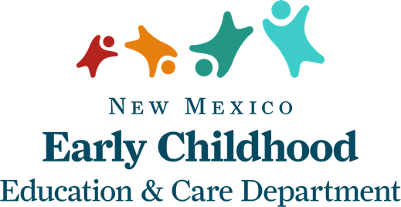

|  |  |
| --- | --- |
| **Licensed Homes** | |
| **Program Type** | **Amount** |
| Private pay tuition only | $3,000 |
| Subsidy 0-50% | $2,400 |
| Subsidy 50% or greater | $2,000 |
|  |  |
| **Licensed Group Homes** | |
| **Program Type** | **Amount** |
| Private pay tuition | $4,000 |
| Subsidy 0-50% | $3,000 |
| Subsidy 50% or greater | $2,000 |
|  |  |
| **Licensed Centers - Private Pay Tuition Only** | |
| **Program Type** | **Amount** |
| Licensed capacity 0-59 | $10,000 |
| Licensed capacity 60-119 | $20,000 |
| Licensed capacity 120+ | $30,000 |
|  |  |
| **Licensed Centers - Private Pay and Child Care Assistance Contracts** | |
| **Program Type** | **Licensed Capacity Amount** |
| Licensed capacity 0-59, 0-50% CCA | $5,000 |
| Licensed capacity 0-59, greater than 50% CCA | $3,000 |
| Licensed capacity 60-119, 0-50% CCA | $10,000 |
| Licensed capacity 60-119, greater than 50% CCA | $6,000 |
| Licensed capacity 120+, 0-50% CCA | $20,000 |
| Licensed capacity 120+, greater than 50% CCA | $15,000 |

Please Note:

A differential of $2,500 will be given to centers that are licensed to serve more than eight children under the age of two.

A differential of $2,000 will be given to centers and a differential of $1,500 to homes at Star 3, 4 and 5.

These amounts will be provided in addition to the amounts listed in this chart.

Over the course of the pandemic, the following financial supports have been provided:

* $250 differential per contract (March and April)
* waiving of parent copays (March - May)
* paying contracts based on enrollment not attendance (March - June)

These financial supports have benefited the state’s licensed facilities and registered homes that serve families who receive child care assistance (CCA). Therefore, facilities who did not benefit from these supports are eligible to apply for a larger amount of funding through the Child Care Stabilization and Recovery Grant.