**Children, Youth & Families Department**

**NEW MEXICO PREK PROGRAM**

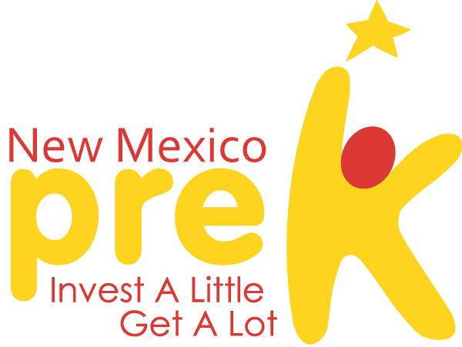

**First Administrative Program Report**

Due: October 15, 2017

**Program Name:**

**Submitted By:**

Select program type: {X}

|  |  |  |  |
| --- | --- | --- | --- |
|  | PreK Basic |  | PreK Extended |
|  | Early Basic |  | Early Extended |

# H:\PreK Logo 07-2011.PNG***C:\Users\clafferty\Desktop\images.jpg*CYFD NEW MEXICO PREK**

**1ST Administrative Report**

***The Office of Child Development (OCD) and New Mexico PreK are currently very focused and dedicated to working as a team on our own Continuous Quality Improvement. For this First Administrative Report, we are asking you to do the same! Look closely at your program CQI, and report on it by answering the questions below. It is our hope that in hearing from you, we can have a better understanding of what is needed from us regarding training and consultation. Please be as thoughtful and descriptive as possible in your responses.***

1. **Please share your understanding of Continuous Quality Improvement (CQI). How do you guide and support your staff to be successful and meet goals regarding quality improvement? *(i.e. peer-to-peer learning, Reflective Supervision, on-going coaching etc.)***
2. **Does your teaching staff understand CQI and its *PURPOSE?* What evidence can you share that demonstrates that understanding? What are the indicators that demonstrate that they could use additional training or support in the area of CQI?**
3. **How does your program include the family’s voice in your CQI goals? What evidence can you share that demonstrates that families know why their feedback and voice is important?**

***Please submit the following documents:***

**Your program and PreK classroom (s) CQI plans.**

**Your annual calendar with scheduled closings and total number of session days noted**