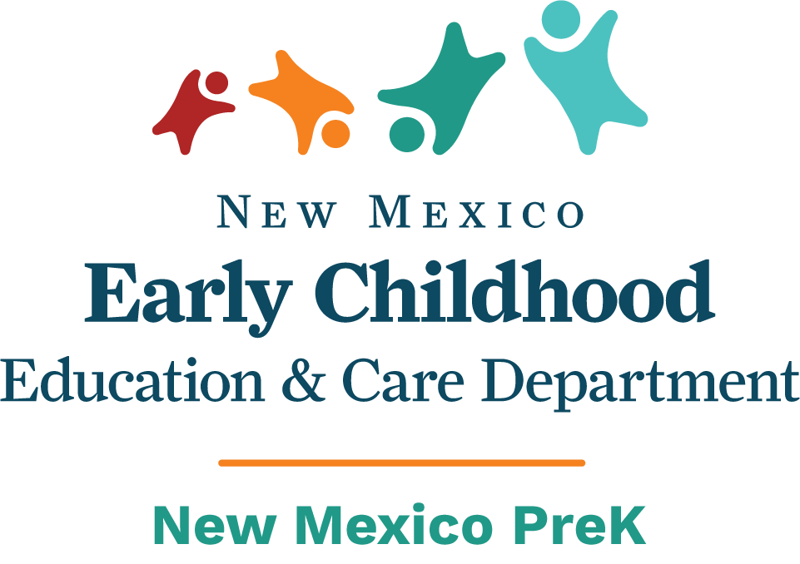
Fall Administrator’s Program Report
Due: November 15, 2022
Program Name:
Submitted By:
Select program type (Check all that apply): {X}
 | Program Type | Funded Enrollment | Actual Enrollment |  | Program Type | Funded Enrollment | Actual Enrollment
 | PreK Basic |  |  |  | PreK Extended
 | Early Basic |  |  |  | Early Extended
 | Mixed-Age PreK Basic |  |  |  | Mixed-Age PreK Extended
Curricula used:

Thank you for your dedication and ongoing work in supporting children and families!
- Professional Learning Development

Please describe how you support and encourage staff in pursuing credentials, degrees and required PreK trainings. Describe your strategies for attracting and retaining PreK staff. What barriers do you encounter and how can we work together to remove them?
Please include information regarding
- number of PreK Teachers currently enrolled in college credit-bearing coursework
- number of PreK Educational Assistants enrolled I college credit-bearing coursework

- Social and Emotional Development
Describe how educators and staff in your program support children’s social emotional development. Include information pertaining to:
- Social and emotional resources utilized
- Strategies implemented through daily routines and schedules
- Adjustments made to classroom environment(s) and adult-child interactions
- Training and strategies implemented to address challenging behaviors in the classroom during the 2022-2023 school year (include the evidenced-based practices of the NM Pyramid or other social emotional models)

- Early Literacy Instruction
Describe how your curriculum addresses early literacy. How are literacy components incorporated as outlined in the NM PreK Program Standards?
- Phonological awareness activities (songs, fingerplays, rhyming, beginning sounds)
- Oral language and vocabulary activities
- Alphabet knowledge activities
- Concepts of print activities
- Daily read aloud activities with comprehension strategies
- Reading to small groups and individual children (include strategies used to ensure that each child is being read to in a small group or individually)
- Daily opportunities for developmentally appropriate writing activities

- Assessment
Describe the program plan to ensure that children will reach the rubric ratings of “accomplished” or” above for their age group” by spring 2023.

- Continuous Quality Improvement: CQI
Describe how your program uses multiple measures to evaluate program compliance and quality. Include the following:
- Child demographics and assessments
- Personnel qualifications
- Administrative practices
- Environmental rating scales
- Coaching and monitoring reports
- Data analysis focusing on improving child outcomes

- Language and Culture:
Describe how your program demonstrates cultural and linguistic responsiveness in all aspects of the program. Include the following:
- Utilizing cultural learning tools that students bring to the classroom
- Promoting development of home language and English
- Completing professional learning related to second language acquisition
- Including materials, books and visuals that reflect the language and culture of children in the classroom
- Ensuring that family engagement opportunities meet the culture, language and literacy needs of children and families
- Administering annual home language survey

- Collaboration and Coordination

Please describe plans for developing new and ongoing partnerships, coordination, and collaboration with school districts, Head Start, Bureau of Indian Education and other early childhood providers in your community. Include plans for quarterly meetings that address coordination of services, address saturation or duplication of services and the sharing of wait lists.

